Answer 9
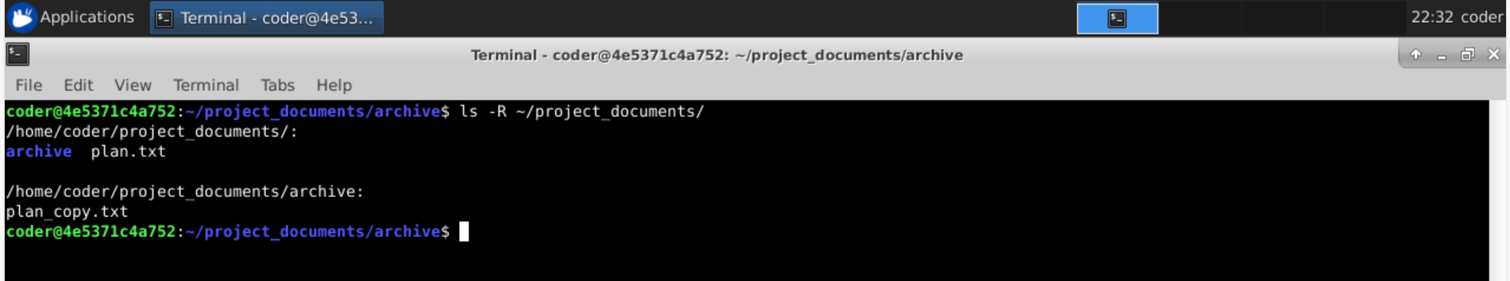
Explanation: By using ls with -R option will show us the all files and directory inside a directory recursively.

